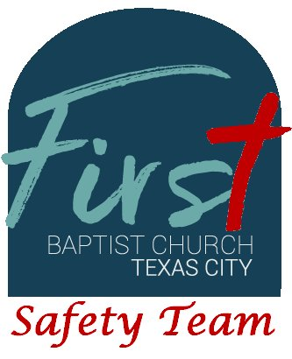
First Baptist Church Safety Team
Training Bulletin #19

Medical Emergencies: Unconscious/Unknown

In emergency medicine, “unconscious/unknown” is a catch-all phrase for unknown medical emergencies, as opposed to trauma injuries. Any time a person is unconscious, it is a genuine medical emergency and requires immediate medical attention.

With the unconscious patient, several steps must be accomplished quickly:

- Is the patient breathing? If the patient is not breathing, immediately reposition the head and neck to open the airway. If the patient does not start breathing on their own, begin rescue breathing (one breath every 5-6 seconds). As a rule of thumb, when you breathe, breathe for the patient.
- Does the patient have a pulse? Check the carotid artery (left and right of the trachea 2-3 finger widths from the midline of the trachea). Count the beats for 10 seconds and multiply x6 for the minute rate. 60-100 is normal, less than 40 or more than 100 requires immediate medical attention. Absence of a pulse requires immediate cardiopulmonary rescuscitation (CPR).
- Survey the surroundings. Is there drugs or drug paraphernalia present? If so, use of Narcan (Naloxone) may be required. Use the flier with the Narcan boxes for further instructions. Check for constricted pupils and sluggish pupils (poor reaction to light).
- Tap and Shout: attempt to arouse the patient. Use the AVPU acronym to determine level of consciousness: (A) Alert and Oriented, (V) Responds to Verbal Stimulii, (P) Responds to Painful Stimulii, (U) Unconscious- no response at all.
- With all medical patients, immediately consider the need for outside EMS. If the patient is conscious and alert, they can refuse treatment, but need attention nonetheless. If the patient is unconscious, we use “implied consent” for treatment, meaning that if the patient would want treatment if they could respond.

Notify the person manning the cameras to contact 9-1-1 and have medical dispatched to the church campus. Send someone to the main entrance to wait for EMS and direct them to the patient. While waiting for EMS, complete several actions (absent of CPR or rescue breathing): Cover the patient to retain heat and prevent shock, obtain baseline vital signs using the available blood pressure cuff and pulse oximeter, and place the patient is a position of comfort (for non-drug use) or left-lateral for possible drug-use patients.
