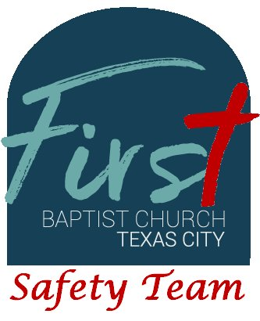
First Baptist Church Safety Team
Training Bulletin #15

Data Protection

Within the medical field and law enforcement field, there are specific laws governing the use and retention of data obtained in the course of business. Federal laws govern how data is collected, how long it is retained and how it is disposed of. This document highlights the methods the Safety Team will utilize.

Data Collection and Retention:

- Medical treatment is covered by HIPAA, the Health Insurances Portability and Accountability Act. Sensitive information, such as a patient's name, date of birth, social security number, insurance intormation is covered under this act. Redacted documents can be shared publicly, but must be used with caution.
- Incident Response Forms, like law-enforcement documentation often includes names, dates of birth, physical addresses, race, sex and other sensitive information. Redacted documents may be shared publicly, but must be used with caution.
- ALL incident reports and witness interviews should be completed and returned to the camera monitoring station at the end of services or when incidents are resolved. These documents should be stored and maintained for a minimum of 10 years, as governed by HIPAA and Texas Penal Code. Electronic copies of these documents must be stored on secure servers, not accessible to the public.
- Summary documents or redacted documents must be requested in writing to the church office as required by the FOIA (Freedom of Information Act). A minimum of two staff members must review all requests and documents for proper redaction before release. Non-redacted documents will be required for legal cases and must be provided in a timely fashion (usually 30 days or less).

