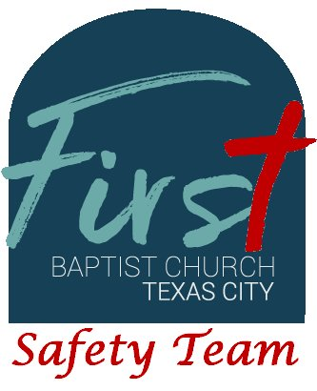
First Baptist Church Safety Team
Training Bulletin #22

Managing Crowds

Crowds present unique challenges in any situation, but are more challenging in a house of worship. Managing crowds in a church setting means balancing crowd control and maintaining a learning and developmental atmosphere.

Churches typically are peaceful environments, but occasions arise where crowds become dynamic, even manic. These events can arise from a single individual inciting a crowd or can come from conversations within the crowd (where the crowd feeds on the words of one or more individuals). Political activities are a good example of this where one or more people are passionate about a given subject and incite a crowd to riot. It is important that our Safety Team members remain dispassionate about what causes a crowd to become animated. In doing so, it is important to remember that you are not only present for the safety of our members, but also representatives of our church, including our beliefs and practices.

When crowds become mobile, we must direct them to areas where they do not disturb the activities of other groups. The children's area is the most sensitive of these areas and children often become confused at what may seem rational to an adult, or may simply follow the lead of an adult they recognize and trust. Like the quarterback on a football team, you must direct other Safety Team members and responsible adults to follow your direction. This may mean you have to be direct and somewhat forceful to disperse crowds or direct them out of the building. As is stated in our “Handling Disruptions” policy, we must remove disruptive individuals to a secluded location and offer them the opportunity to speak with members of the staff at times where it does not disrupt worship services, Sunday School or other activities. Never attempt to handle individuals such as this one on one. Use the radio or direct communication with other Safety Team members to assist, so that conversations do not become he said, she said instances (multiple witnesses to any conversation are preventative in nature).

Other circumstances that tend to incite others to action include individuals with mental disturbances, individuals with an agenda, and individuals with developmental delays. Remain calm, and attempt to re-direct the individual(s) to other activities, distractions, or other people who do not readily react to what an individual says or does. If these efforts are unsuccessful, enlist the services of the campus police officer, or call 9-1-1 for assistance. Remember that if an individual must be removed from the church campus, a staff member should be involved unless the individual represents a clear danger to others or themselves.

