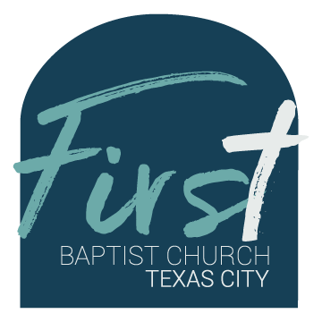
First Baptist Church Safety Team
Training Bulletin #1

4 Mistakes Church Safety Teams Make

- Focusing too much on active shooters.
Active shooter incidents are the least common situation churches see happening. Too often, it is other disturbances that Safety Teams see on a weekly basis. These may include: Protestors, Mentally Ill Individuals, Naturally Disruptive People.
- Too many open entrances.
Multiple open entrances multiplies the chances of having disruptions during services. Closing entrances should no prohibit people leaving the building. If you can reduce the number of entrances to 1 or 2, you enhance the abiltity to stop disruptions before they start.
- Not taking the task seriously enough.
In the age of technology, it's too easy to be distracted by other things, such as phones, tablets and monitors. Dilligence on the job is key to making the Safety Team successful.
- Not being focused on training.
Continuous training is necessary to maintain skill sets. Training should include classroom training, focus groups and for armed security, range time. At a minimum, this should be done multiple times per year.
Source: Church Security Answer Man
https://www.youtube.com/watch?v=tlgOqjExbpo
http://www.churchsecurityanswerman.com

