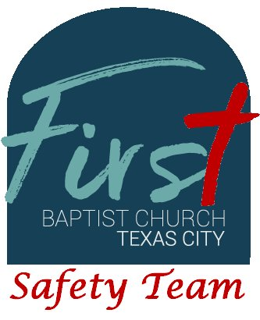
First Baptist Church Safety Team
Training Bulletin #18

Layers of Awareness

Being a member of a church safety team is more than making rounds and making sure doors are locked. When an active shooter is present, every second represents a potential life taken. Society is less respectful, and society is more violent.

Are you, as a Safety Team member, aware of what is “normal?” Are you prepared to implement de-escalation techniques? Are you prepared to use situational awareness?

- 65% of all incidents at houses of worship happen outside the building

When encountering an individual who desires to disrupt our congregation or threatens one of our members, use the following steps to bring the situation under control:

- MEET & GREET: Identify yourself and your title.
- EXPLAIN THE REASON FOR THE ENCOUTER: Tell them why you are there.
- ASK QUESTIONS: Ask if they have any justification for their behavior.
- STATE THE OPTIONS: Explain to the them why they need to cooperate and what behaviors will not be allowed.
- CALM: Remember to remain calm and speak in firm tones as needed.

As members of the Safety Team, you are just as valuable as the ministerial staff and church greeters. You should be one of the first people that visitors and new members see on any given Sunday. A welcoming smile is just as important as any of the tools that you have available. When greeting visitors, offer them a trip to the coffee bar and a guided tour of the campus. Show them what Sunday School classes are available for them and their family. Introduce them to staff members and other congregation members to develop new friendships.

