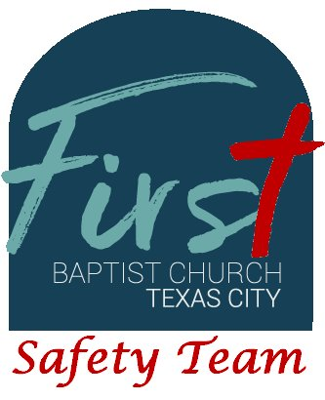
First Baptist Church Safety Team
Training Bulletin #25

To Carry or Not To Carry

Texas recently passed the constitutional carry act (HB1927) in 2021, ending the requirement for an LTC (License to Carry) license for residents of the state of Texas. Today, we will look at the various signage that regulates when a weapon may be carried on a given premise.

The first sign we will examine is the Texas Penal Code § 30.05 sign, which states: “Pursuant to Section 30.05 Penal Code (Criminal Trespass), a person may not enter these premises with a firearm.” This sign may also be represented in picture form with a handgun with a red circle with a diagonal line through it. The sign is usually black lettering on a white background with letters 1” in height. This sign means the property owner prohibits all firearms, concealed and open.

The next two signs, Texas Penal Code § 30.06 and 30.07, prohibit the carry of concealed and openly carried firearms. The signs read: “Pursuant to Section 30.06/30.07, Penal Code (trespass by license holder with a concealed/openly carried handgun), a person licensed under Subchapter H, Chapter 411, Government Code (handgun licensing law), may not enter this property with a concealed/openly carried handgun.” The sign is usually black lettering on a white background with letters 1” in height. First Baptist Church has posted § 30.07 (open carry) signs at the north, south and east entrances. Only law enforcement and paid security are allowed to openly carry inside our facility. These signs are typically displayed at churches, schools, government buildings, state parks and wherever the property owner does not permit licensed gun owners to carry firearms.

The next sign, now null and void, is usually located on premises where alcohol is sold but not consumed (liquor stores and convenience stores). The sign states: “Notice: The unlicensed possession of a weapon on these premises is a felony with a maximum penalty of 10 years imprisonment and a fine not to exceed $10,000.” These signs were initially instituted by TABC (Texas Alcohol Beverage Commission). The passage of the Texas License to Carry (formerly know as the Texas Concealed Carry Act) nullified these signs and TABC no longer requires these signs to be posted.

The “51%” sign is the most commonly misused sign. Any premises that generates 51% of its revenue from the sale of alcohol and consumed onsite, typically only bars and nightclubs, must post this sign: “NOTICE: It is unlawful for a person to carry a weapon on this premise, including those licensed under Subchapter H, § 411, Government Code.” Some signs list the fines as a maximum of 10 years imprisonment and a fine not to exceed $10,000. If this sign is posted on a restaurant that also serves alcohol, they are in violation of TABC (Texas Alcoholic Beverage Commission) rules.

Examples of the signs are as follows:

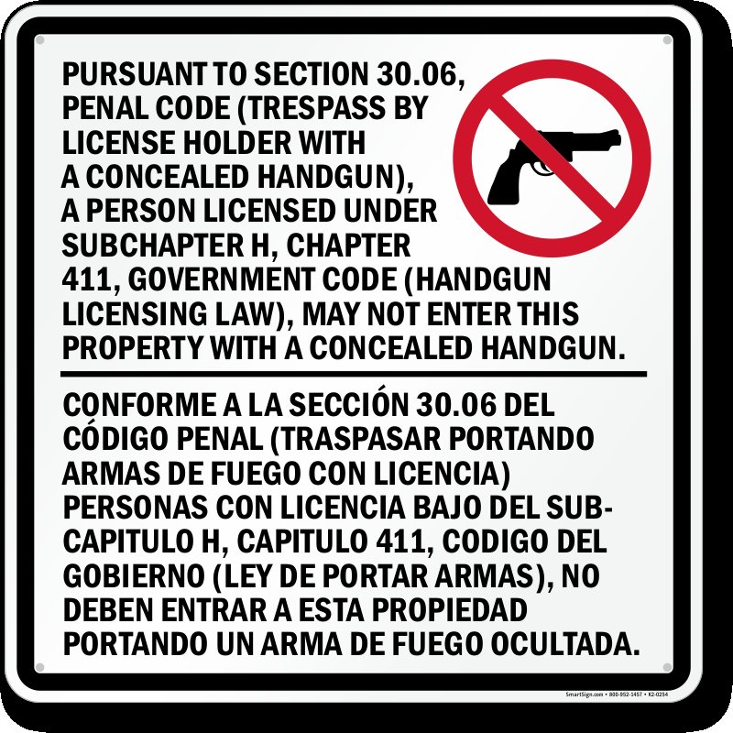 | 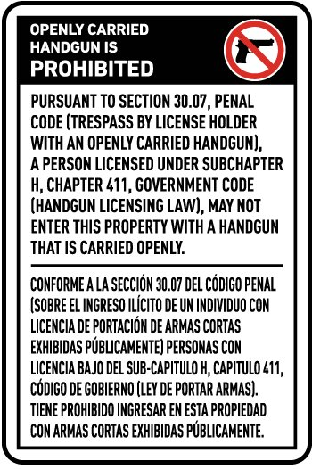
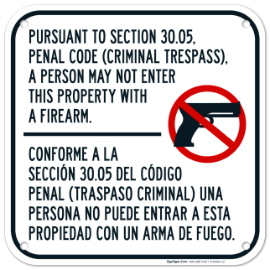  Note: The Section 30.05 sign is no longer valid and should not be used in the state of Texas. | 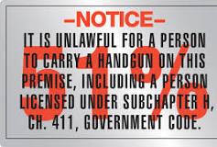

Sign sizes may vary. See Texas Penal Code § 30 for further details. The 51% sign is regulated by the Texas Alcoholic Beverage Commission.

