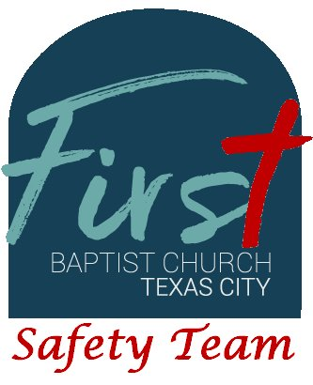
First Baptist Church Safety Team
Training Bulletin #17

How Do Congregations Feel About Church Security

Have you ever wondered how First Baptist Church Texas City compares to other churches? Based on the following statistics, FBCTC would be in the top 1/3 or all churches responding to this survey. The following statistics are taken from Lifeway Christian Resources...

- 73% of churchgoers say they feel more safe when seeing a uniformed policeman or security guard at church
- When asked, pastors said their churches have the following measures in place when their church meets for worship:
  - 61% of churches have an intentional plan for an active shooter
  - 45% of churches have armed church members
  - 28% of churches have radio communication among security personnel
  - 27% of churches have a “no firearms” policy for the building where they meet
  - 23% of churches have armed private security personnel on site
  - 6% of churches have uniformed police officers on site
  - 3% of churches have metal detectors at the entrances to screen for weapons
-AND-
  - 18% of churches have none of these

