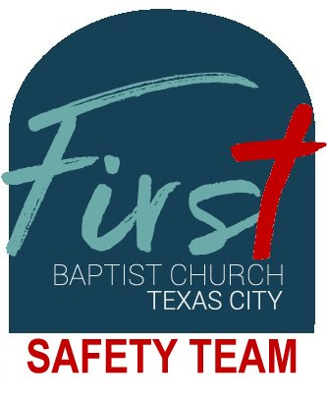 | First Baptist Church Texas City  Safety Team Instructions  Operations Manual: Duty Stations

The Safety Team was founded to provide for the protection of the congregants attending Sunday School and Worship Services at the First Baptist Church Campus.

Mission Statement:
To foster a worshipful environment free of (cultural) anxiety.

Duty Stations:
- East Door/Foyer Attendant
- Children's Area Attendant
- Baptistery Attendant
- Camera Monitor
- Worship Attendants

As is obvious, the East Attendants should be stationed near the main entrance to the building and should also be responsible for their parking areas. The baptistery attendant should be posted in a position to observe the north, south and east entrances.The intent is to prevent threats to our members before they gain access to the building, and the camera monitor will assist in monitoring these areas. Additionally, the golf cart attendant will assist monitoring the parking areas.

During Bible study and between services, each of the first 5 areas should be attended and monitored. The person assigned to the baptistery can assist any of the three entrance attendants. When services are approaching, the congregation attendants should take key positions at the front of the congregation. The Safety Team members who are attending entrances may also occupy these positions. The mission of the church is to provide the message of God to the world, and it is also important for Safety Team members receive the message.

When services are in session, several members of the Safety Team will have duty responsibilities. In most cases, people who wish to do harm at church services generally wish to target leadership and inflict maximum damage. To this end, as a Safety Team member, your responsibility is to ensure the safety of staff and congregants. The Congregation Attendants stations are responsible for evacuating the congregation in the event of an emergency. The Worship Attendants are responsible for the pastor and Praise Band. The attendants will escort members out of the sanctuary and to the closest exit (typically, the main (east) exit). If the pastor is on stage, the Stage attendants primary responsibility will be to escort the pastor out the rear of the stage (exits are to the left and right of the stage). If the Praise Band is on stage, they should also be escorted off-stage via the closest appropriate exits. It is important to note, that with all populations, there will be members who have limited mobility, and special attention should be given to ensure their safety as well (utilize other members to assist in this task). When services are in session, the off-duty police officer will be in the foyer, and his responsibility will be to report and assist the Safety Team members in neutralizing threats to the congregation. The person assigned to the baptistery should assist members to exit the building and direct members to the muster point.

Between services and before and after Sunday School, rounds should be made to verify all unattended entrance/exit doors are secure. These doors are located in the northeast corner, southeast corner, the end of the hallway adjacent to the kitchen/skullery, and the loading dock. Additionally, doors that access the staircase on the north end of the building should be secure and the freight elevator should be on the ground floor with the doors open.

