
First Baptist Church Safety Team
Training Bulletin #3

Non-Lethal Alternatives to Firearms

This is not intended to be a philosophical discussion about the ownership and use of firearms for self-defense and public defense. It is up to each individual to decide what is right for you and your family.

First Baptist Church Texas City posts signage at each location prohibiting the open carry of firearms (Texas Penal Code § 30.07). The only exception to this law is those authorized under state statutes to openly carry at all times, such as police officers or paid armed security. We do not discriminate against individuals who wish to conceal carry on campus. As members of the Safety Team, you are encouraged to conceal carry, but not required. There are several several alternatives to lethal weapons that you may choose to carry, and the advantages and disadvantages are listed with each type of weapon.

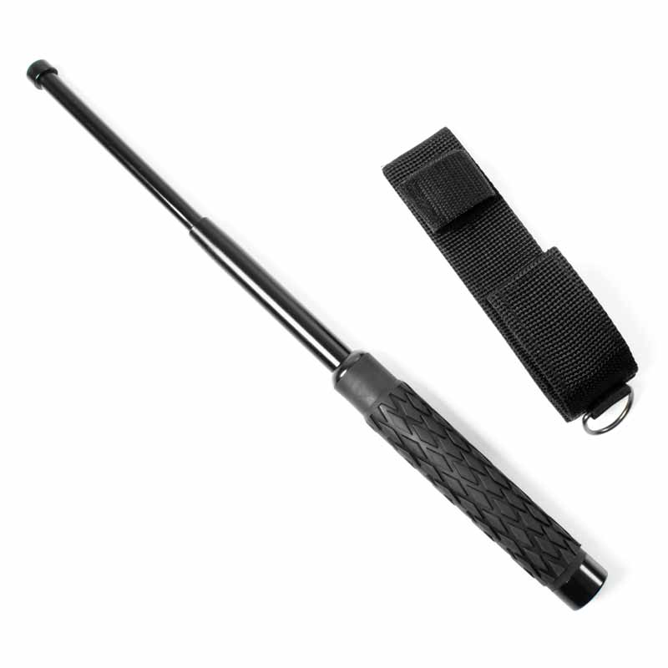
Baton-Type Weapons: while formal training is not required, it is highly recommended so that you may use this type of weapon effectively. Advantages are that its mere presence acts as a deterrence to continued disobedience. Disadvantages include: having the weapon taken away from you, and the requirement for close contact with the offender.

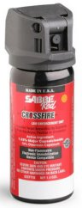
Pepper Spray (Oleoresin Capsicum or OC Spray): this is another type of non-lethal weapon that training is highly recommended. Advantages are that this weapon does afford some distance between you and any potential offender. The main disadvantages to using OC spray is that it will contaminate a large area (and in most cases, yourself), requiring decontamination and potential exposure to other members of the congregation. The biggest disadvantage comes when you are forced to use OC spray and are called to testify in court. One of the first things asked of you will be “what is your level of training, and have you ever had to be sprayed with OC spray yourself?”

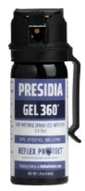
Mace-Type Sprays (aka 'Tear-Gas'): These types of non-lethal weapons require minimal training, but training is recommended. Advantages for this type of weapon include rapid incapacitation of the offender and rapid neutralization. While once restricted to law enforcement and military, these are now available to the public, but may be limited in the size of this weapon you may possess. The only disadvantage of using this type of device is that it requires you to be in close proximity.

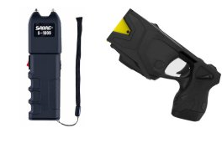
Stun-Guns: Stun guns are an affordable, non-lethal weapon commonly carried today. Many of the stun guns in use today are high-voltage, low amperage devices that render an offender immobilized immediately. Advantages include being able to have “stand-off” distance between the Safety Team member and the offender for wired devices (Tasers© and similar), rapid recovery from use of these devices, and affordable prices. Disadvantages include having to have physical contact with the offender when using the compact version of these devices and the possibility of accidental shocks to the user. These devices also carry some risk to elder offenders and victims with known cardiac issues.

Prices for all of these devices generally runs under $50, but Taser© devices (and similar) run up to $400. All of these devices are easily concealable and easy and quick to deploy.

